**Microprocessor Systems and Interfacing**

**Submitted By:** Rabia Khan (FA17-BCE-004) **Submitted to:** Dr. Shahid Mustafa Huzaifa Saleem Khan (FA17-BCE-016) **Submitted Date:** June 25th, 2021.

Meer Balach Khan (FA17-BCE-029)

***CEP Report***

***CALCULATOR using PIC18F452***

**INTRODUCTION:**

This project focused on design and implementation of a microcontroller based calculator which will perform simple arithmetic using switches and a 16x2 Liquid Crystal Display (LCD). It takes 15-bit data through switches which are connected at PORT B and other two switches are connected on port C and their different configuration will do different arithmetic operation (e.g., 00 for addition, 01 for subtraction). This allows the program for the arithmetic operations to be simple. The results obtained are displayed on the LCD display.

**PIC Microcontroller architecture** is based on Harvard architecture and supports RISC architecture (Reduced Instruction Set Computer). PIC microcontroller architecture consists of memory organization (ram, rom, and stack), CPU, timers, counter, ADC, DAC, serial communication, CCP module and I/O ports. PIC microcontroller also supports the protocols like CAN, SPI, UART for interfacing with other peripherals.

We are using **PIC Assembly and C language programming** to code the calculator using PIC 18F452 Microcontroller for Proteus and MPLAB.

**PIC Input/output ports** will be used for data input and output. Input on which the operation has to be performed will be allotted through input ports and after the calculation the output will be displayed through output ports.

For data transmission **Serial Communication** will be used. UART (Universal Asynchronous Receiver Transmitter) is a serial communication interface which is used for transmitting and receiving data. The UART feature is first initialized and then it can be used for transferring data.

PIC Microcontroller consists of both Hardware and Software **Interrupts**. If the interrupts are generated by external hardware at certain pins of microcontroller, or by inbuilt devices like timer, they are called Hardware Interrupts. While Software interrupts are generated by a piece of code in the program. Here software interrupts could occur.

**Literature Review:**

The sources we are using for this project are:

* For schematic and simulation we are using Proteus software:
* For coding the microprocessor we are using MPLAB.
* Following guidelines from:
  + Online research paper and articles.
  + Microprocessor coding online lectures/tutorials
* **Proteus Design Suite :**

The Proteus Design Suite is a proprietary software tool suite used primarily for electronic design automation. The software is used mainly by electronic design engineers and technicians to create schematics and electronic prints for manufacturing printed circuit boards.

**Proteus Design Suite:**

Proteus PCB tools seamlessly combines schematic capture and PCB layout to provide a powerful, integrated and easy to use suite of tools for professional PCB Design.

It can be purchased in many configurations, depending on the size of designs being produced and the requirements for microcontroller simulation. All PCB Design products include an auto-router and basic mixed mode SPICE simulation capabilities.

* **MPLAB :**

MPLAB is a proprietary freeware integrated development environment for the development of embedded applications on PIC and dsPIC microcontrollers and is developed by Microchip Technology. MPLAB X is the latest edition of MPLAB and is developed on the NetBeans platform.

MPLAB is designed to work with MPLAB-certified devices such as the MPLAB ICD 3 and MPLAB REAL ICE, for programming and debugging PIC microcontrollers using a personal computer. PICKit programmers are also supported by MPLAB.

**SCHEMATIC DIAGRAM:**

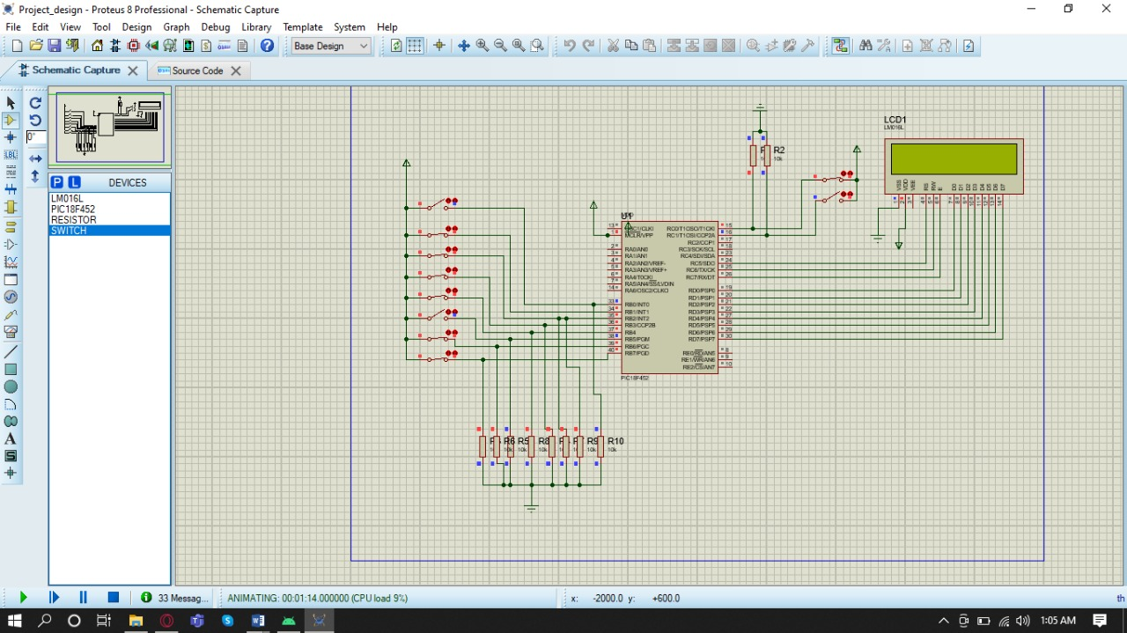

**Flowchart:**

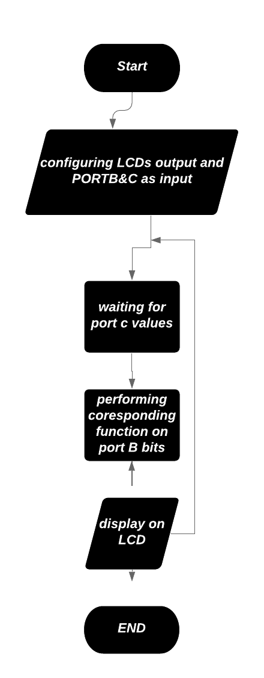

**Method:**

**Theory of Design**

The circuit for a calculator which will perform simple arithmetic operations in the PIC 18F452 Microcontroller, using a calculator keypad and 16X2 LCD display, is shown inFigure1. The keypad has 16 keys: 10 numeric buttons, 4arithmetic operations, equals and clear. The results obtained are displayed on the LCD display

**Desired Output**

The calculation and result are displayed. For the divide operation, the result is displayed as result and remainder. The clear key erases the current display, and a new calculation can be entered. If an invalid key sequence is entered, the program should be restarted.

**Addition (00):**

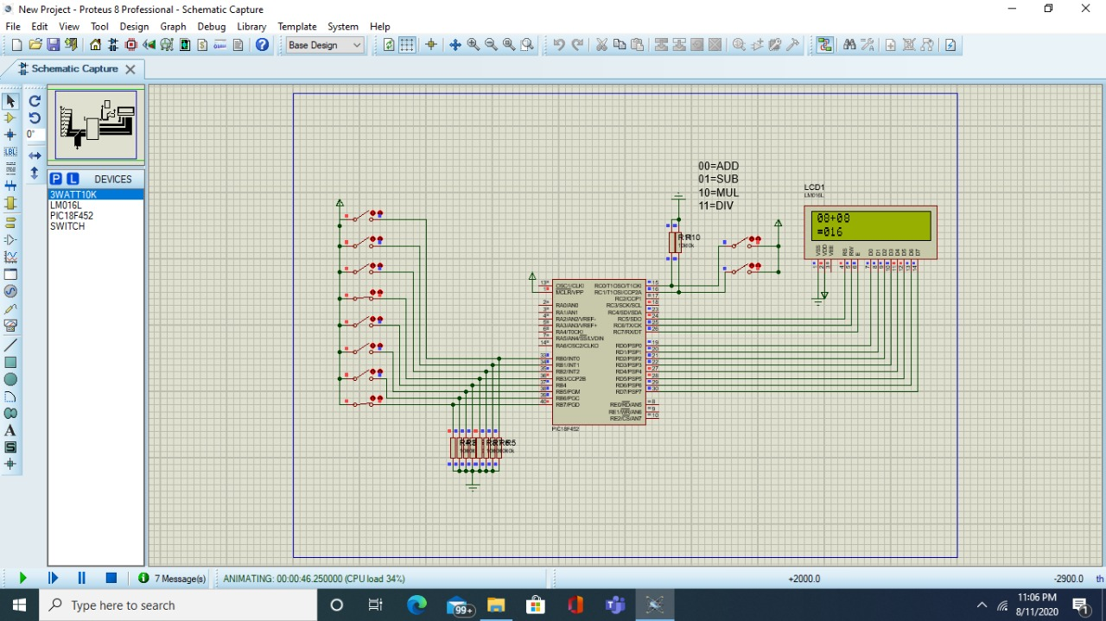

**Subtraction (01):**

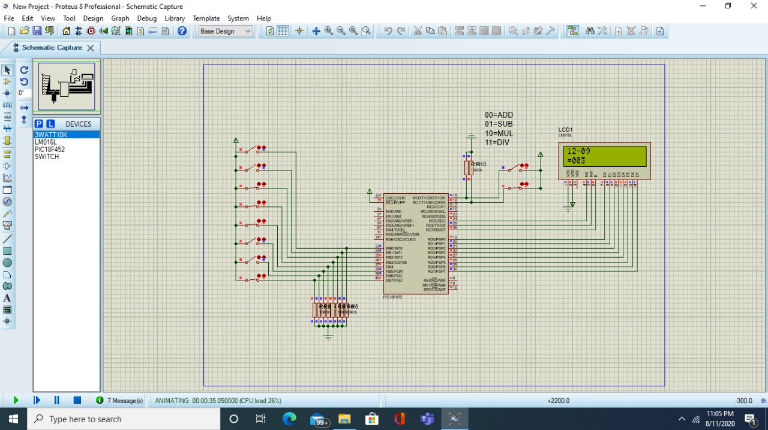

**Multiplication (10):**

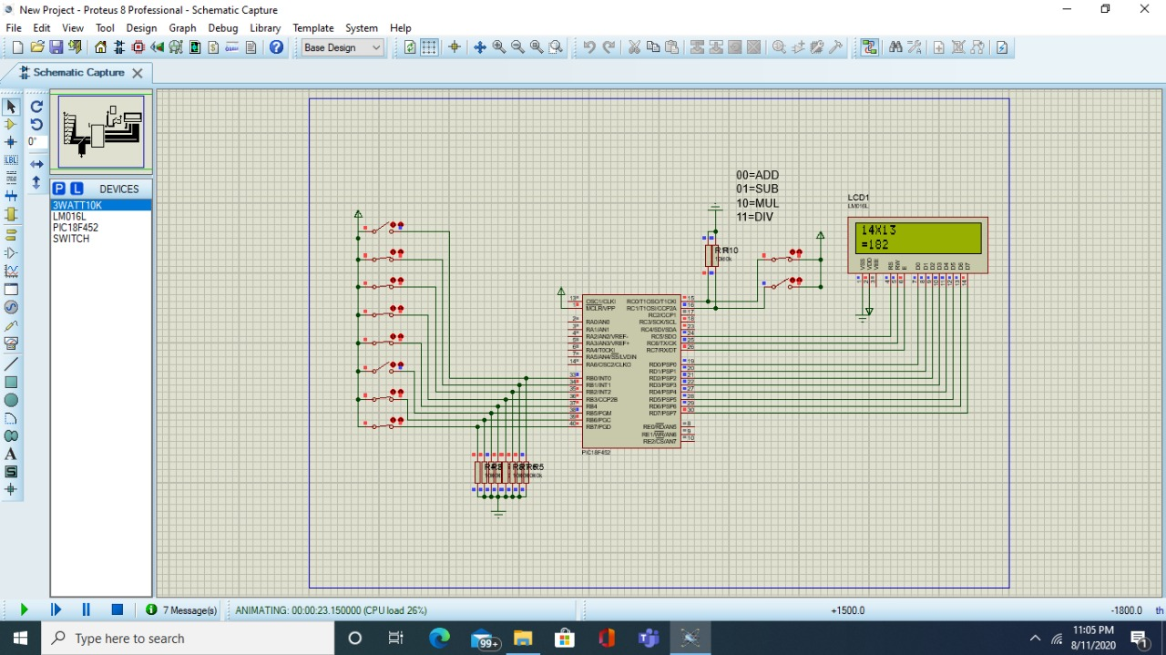

**Division (11):**

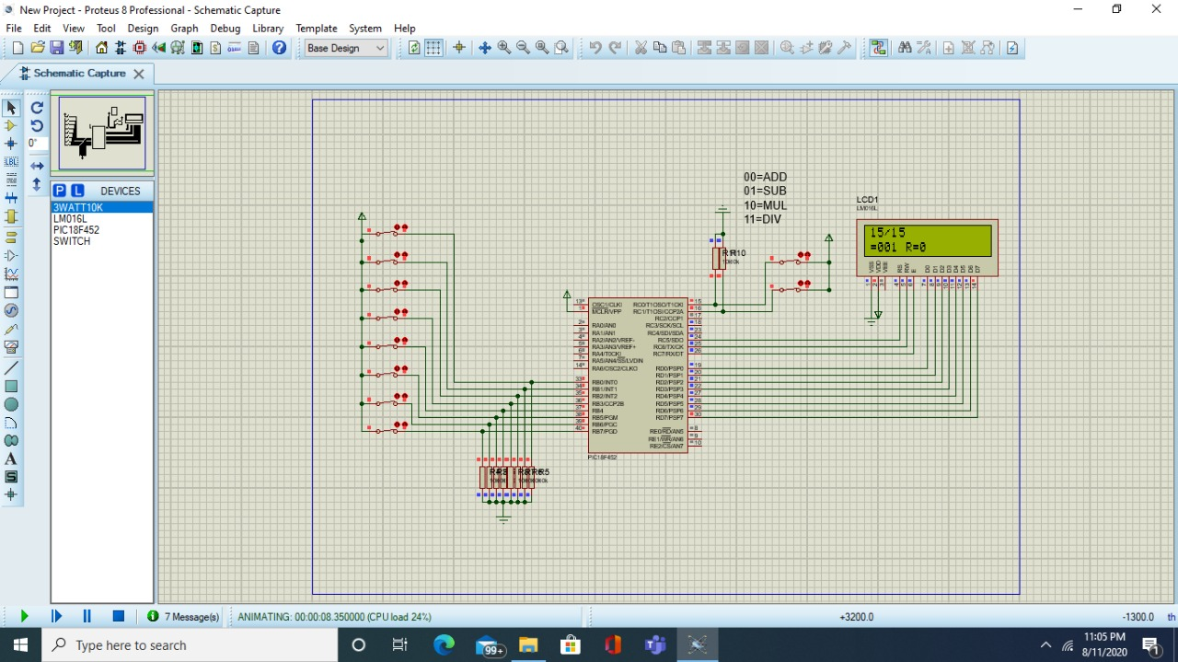

**Components using:**

1. Pic18F452
2. Character LCD 16x2
3. 4Mhz Crystal
4. 3W 10k resistors
5. 10k preset (variable resistor)
6. Switch

In PIC18, all the ports that were used as output has to be changed from PORTx to LATx to make them work.

In this project we will create a Calculator by using **PIC18F452**, in total **10** switches will be used where 4 switches will be used for higher bits and 4 will be used for lower bit value other 2 switches will be connected at PORT C are used for deciding the arithmetic operation.

Where 2 switches which are connected to Port C having value of **00** will perform **Addition operation**, **01** will perform **Subtraction Operation**, **10** will perform **Multiplication Operation** and **11** will perform **Division Operation.**

_____________________________________________________________________________________